Blood Center Logo’s

- Login Page (WS_Blood_Centers_Aligned.png):

donor/cac_login.css (.loginCanvas)
.loginCanvas {
type:canvas
//gradient-colors:r255g255b255,r235g235b235,.2
gradient-colors:r171g212b238,r238g243b249,.1
gradient-vcycle:/1
gradient-hcycle:0
//image1:/images/CTS_banner.png,LEFT,TOP,1,800,124
//image2:/images/WS-Blood-CentersDT-Logo.png,390,440,1,-1,-1

//image1:/images/MGH.jpg,CENTER-IMAGEWIDTH/2,TOP,0.3,-1,-1
//image2:/images/MGH_logo.jpg,LEFT,TOP,1,-1,-1

//image1:/images/WS-BloodCenters-Former-AlignLogo.png,CENTER-IMAGEWIDTH/2,1,1,-1,-1
image1:/images/WS_Blood_Centers_Aligned.png,CENTER-IMAGEWIDTH/2,1,1,500,53

}

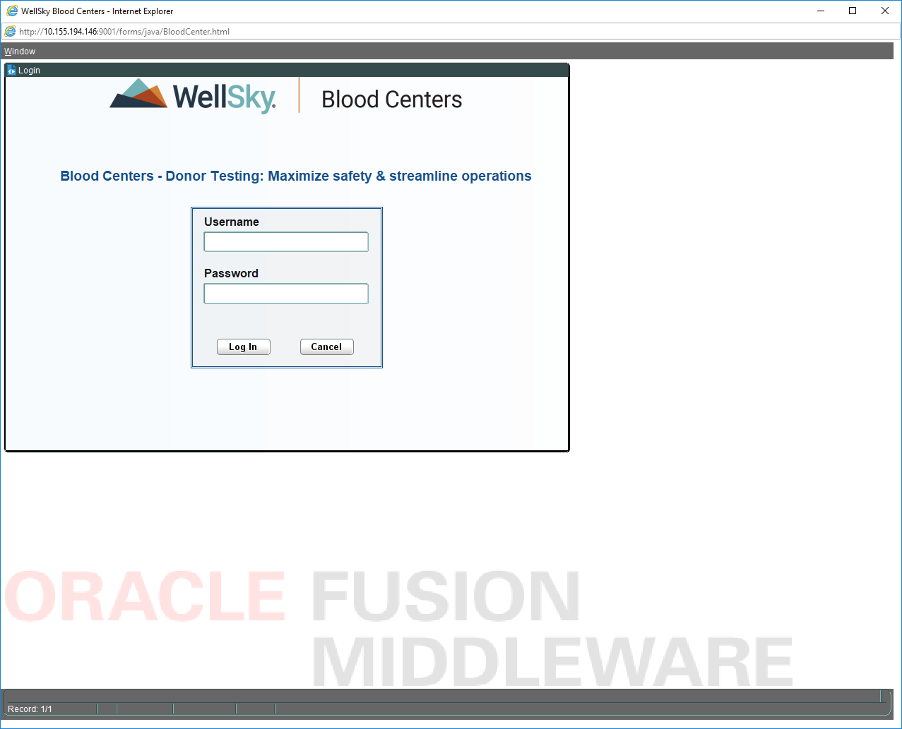

- Donor Menu (WS_Blood_Centers_Stacked.png)

donor/forms_laf.css (.bannerCanvas1)
.bannerCanvas1 {
type:canvas
gradient-colors:r178g211b211,r178g211b211,.2
gradient-vcycle:/1
gradient-hcycle:0
//image1:/donor/lifetrak_logo_red.jpg,705,10,1,85,34
//image1:/images/WS-BloodCenters-StackedLogo.png,694,5,1,85,34
//image1:/images/WS-BloodCenters-Former-StackedLogo.png,694,5,1,-1,42
image1:/images/WS_Blood_Centers_Stacked.png,694,5,1,100,47
}
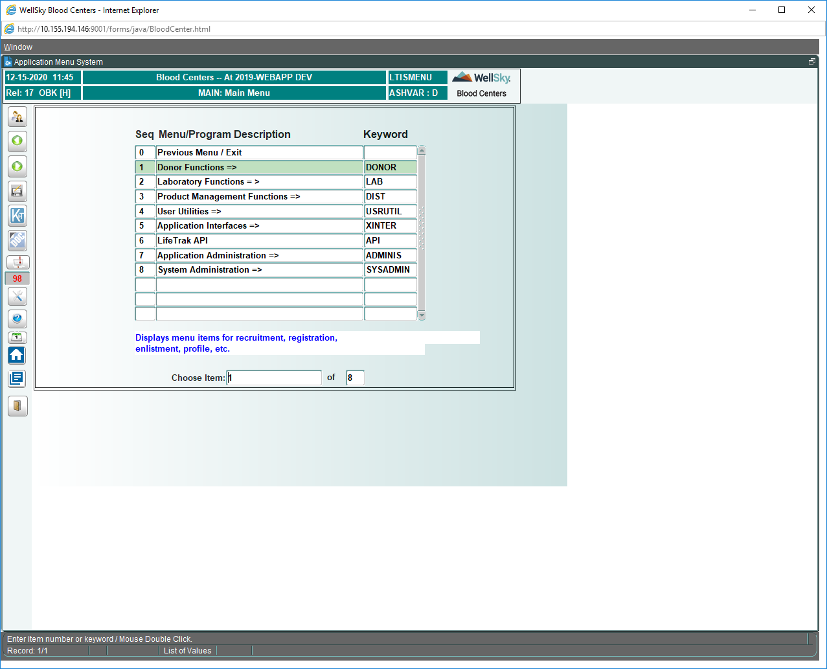

- Donor Screens (WS_Blood_Centers_Stacked.png):

donor/forms_laf.css (.bannerCanvas)
.bannerCanvas {
//image1:/images/LTLogo1.png,694,5,1,107,44
//image1:/images/WS-BloodCenters-Former-StackedLogo.png,694,5,1,-1,42
image1:/images/WS_Blood_Centers_Stacked.png,694,5,1,100,47
}

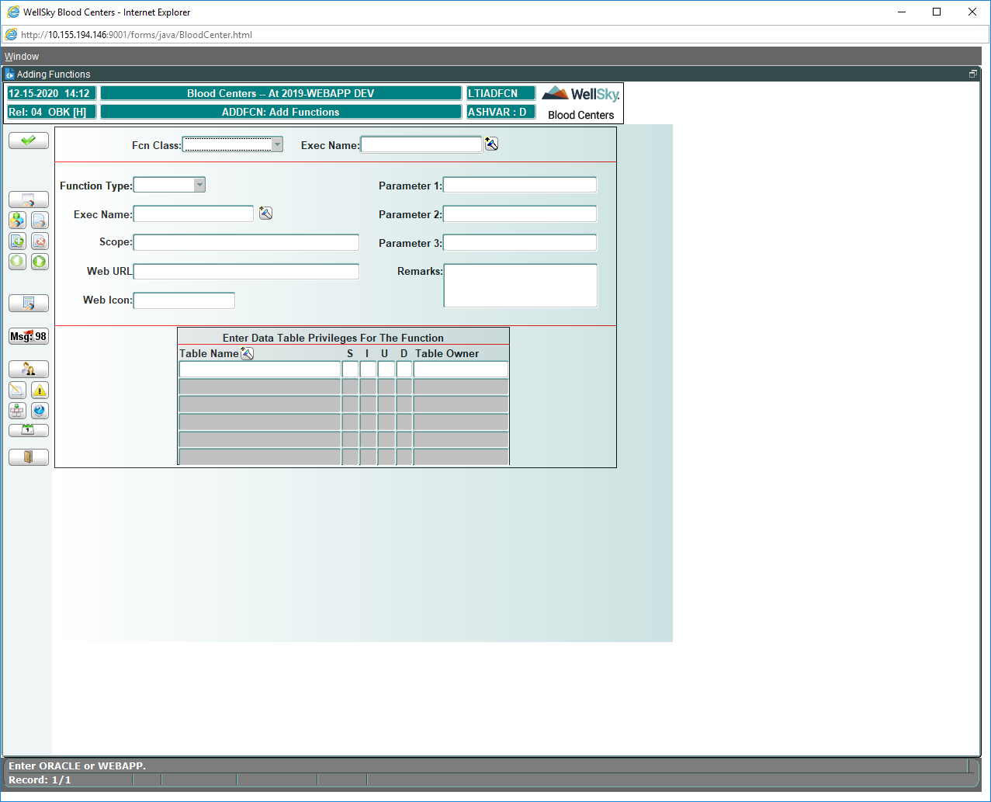

- LAB Screens (WS_Blood_Centers_Stacked.png):

donor/lab.css (.canvas1)
.canvas1 {
type:canvas
gradient-colors:r255g255b255,r0g95b158,.4
gradient-vcycle:/1
gradient-hcycle:0
//image1:/donor/lifetrak_logo_red.jpg,650,20,1,85,34
//image1:/images/WS-BloodCenters-Former-StackedLogo.png,645,15,1,-1,42
image1:/images/WS_Blood_Centers_Stacked.png,645,15,1,90,42
}
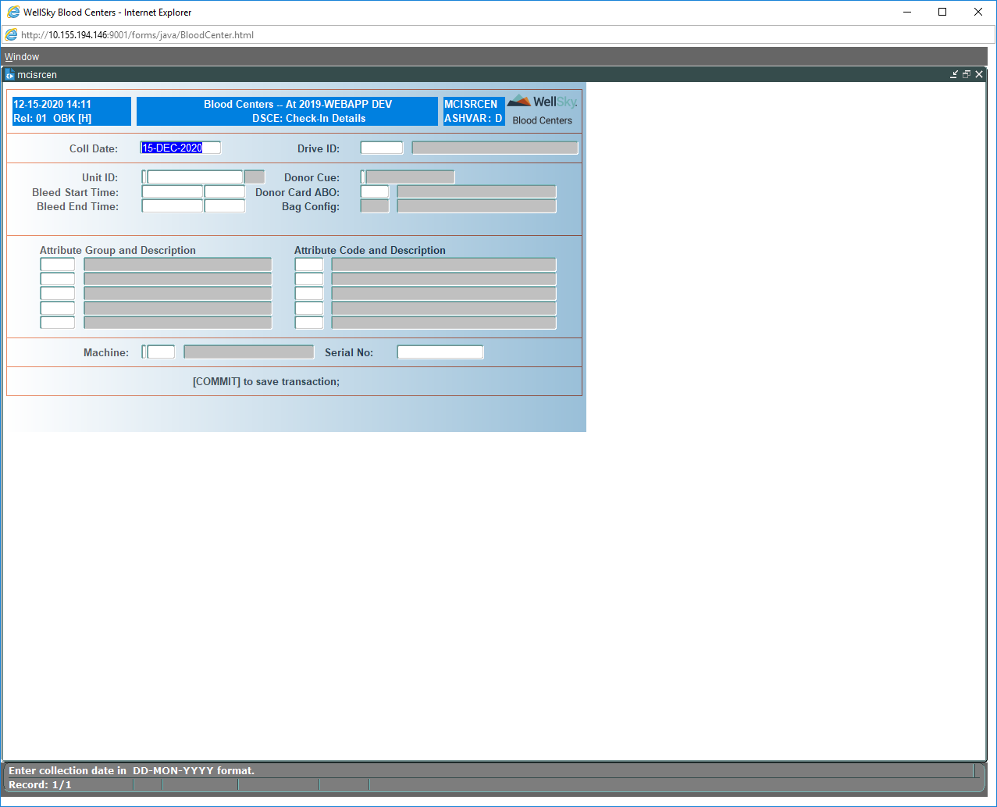

ADDITIONAL INFORMATION:

Location of images:
/apps/Middleware/Oracle_Home/forms/java/images

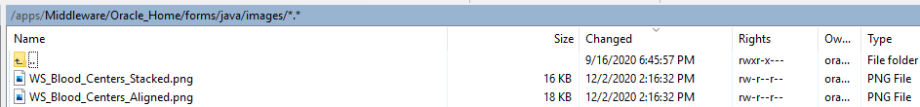

Image tag in css:
/* image scaled to 300 pixels width and keep aspect ratio on height axis */ Image: c:/images/image2.jpg,100,1,.5,300,-1

/*
x pos: CENTER-IMAGEWIDTH/2
y pos: 1
transparency level: 1 (any value between 0 and 1)
width: 500 px
height: 53 px

*/

image1:/images/WS_Blood_Centers_Aligned.png,CENTER-IMAGEWIDTH/2,1,1,500,53

